3-PHASE POWER INVERTER

Guide to operate the 3-phase inverter experimental setup  
([v.morais@fe.up.pt](mailto:v.morais@fe.up.pt))

# Features

* The 3-phase 30A@450V power inverter for academic/research purposes;
* This inverter has built-in measurements of AC currents, AC voltages and DC bus voltage;
* The inverter is based on infineon IPM IKCM30F60GA module (a low-cost module, with integrated drivers);
* The control board is based on XMC4500 Relax (lite) kit, a well-known board in UP Laboratory of Power Electronics;

# SCHEMATIC

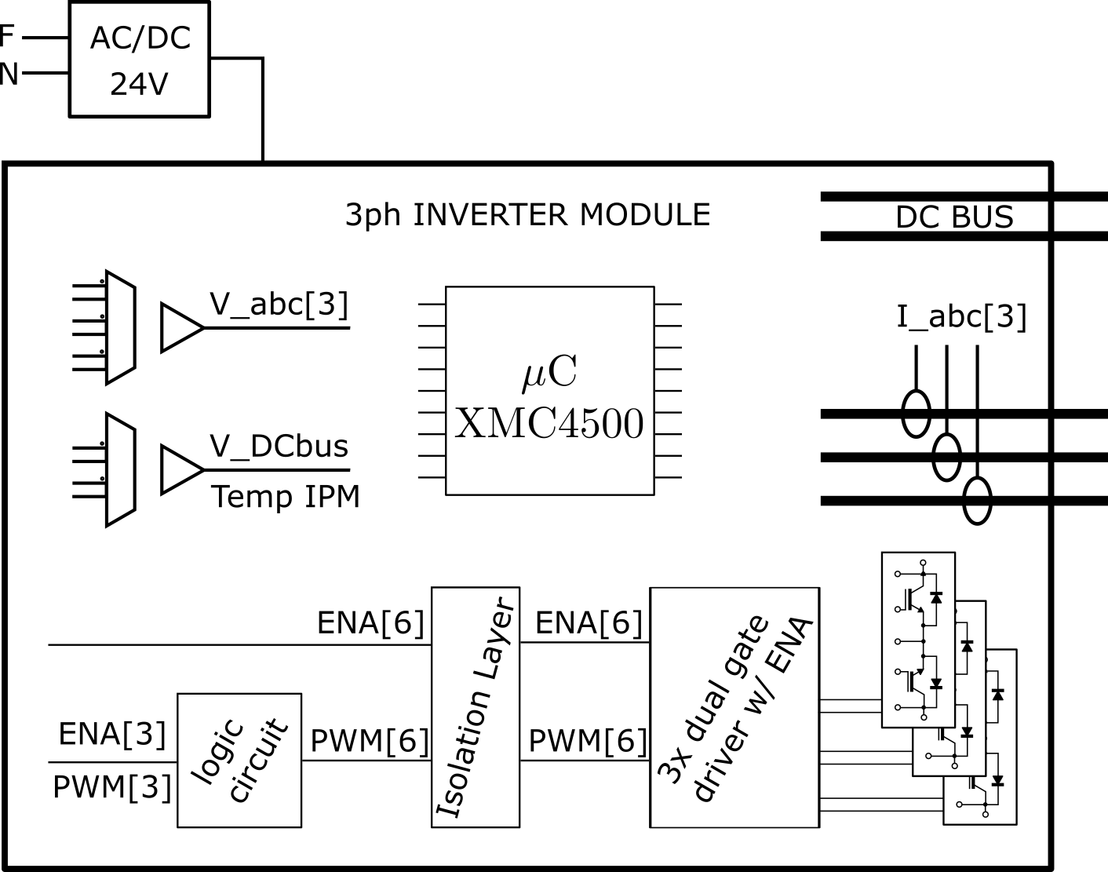

Figure 1 - general schematic.

# PWM Generation waveforms

The PWM generation implemented in this power inverter module uses the following logic circuit:

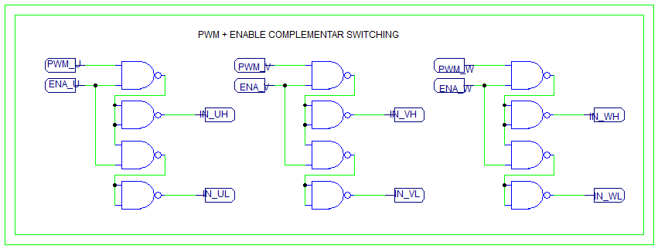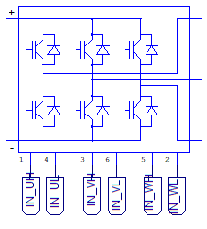

Figure 2 – Detail of logic circuit for PWM generation.

This arrangement allows the generation of two complementary PWM for each inverter arm. In addition, there is an enable signal for each inverter arm.

These signals pass through an isolation layer, and later though three dual gate drivers, with enable, for each transistor, following:

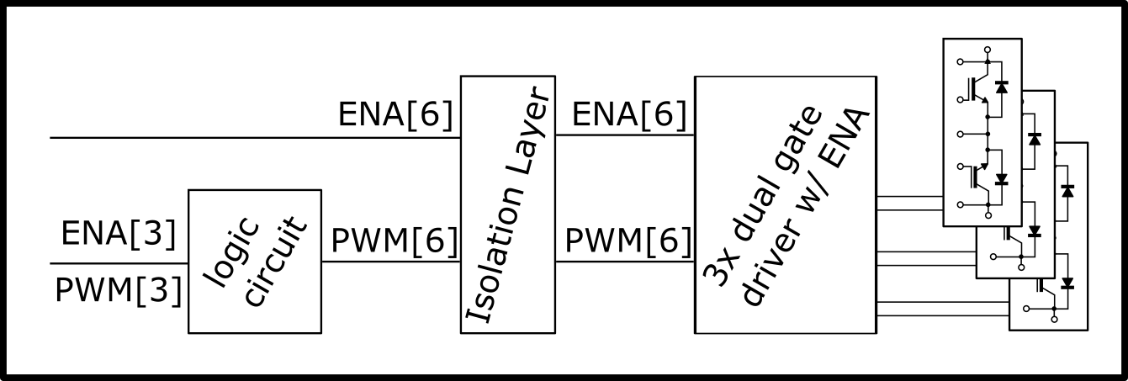

Figure 3 - General PWM generation.

On the XMC4500 side, the PWM pins are the following:

|  |  |  |
| --- | --- | --- |
| Functional pin | XMC4500 pin | description |
| PWM U | P0.4 | Pwm signal |
| PWM V | P0.6 | Pwm signal |
| PWM W | P0.5 | Pwm signal |
| ENA U | P2.6 | Enable arm U |
| ENA V | P5.2 | Enable arm V |
| ENA W | P5.0 | Enable arm W |
| iso_ENA_UH | P0.2 | Enable arm U high side IGBT |
| iso_ENA_UL | P3.2 | Enable arm U low side IGBT |
| iso_ENA_VH | P0.11 | Enable arm V high side IGBT |
| iso_ENA_VL | P3.1 | Enable arm V low side IGBT |
| iso_ENA_WH | P3.3 | Enable arm W high side IGBT |
| iso_ENA_WL | P3.0 | Enable arm W low side IGBT |

# Acquisition of electric waveforms

This setup has built-in measurements of electric waveforms, specifically three currents (for each of the phases), the DC voltage and three AC isolated voltage measurements.

## Current Measurements (three internal measurements)

The current measurement is performed with an isolated hall effect based current sensor, specifically the ACS713ELCTR-20A-T. The maximum value for the AC current sensor is +/- 20A peak.

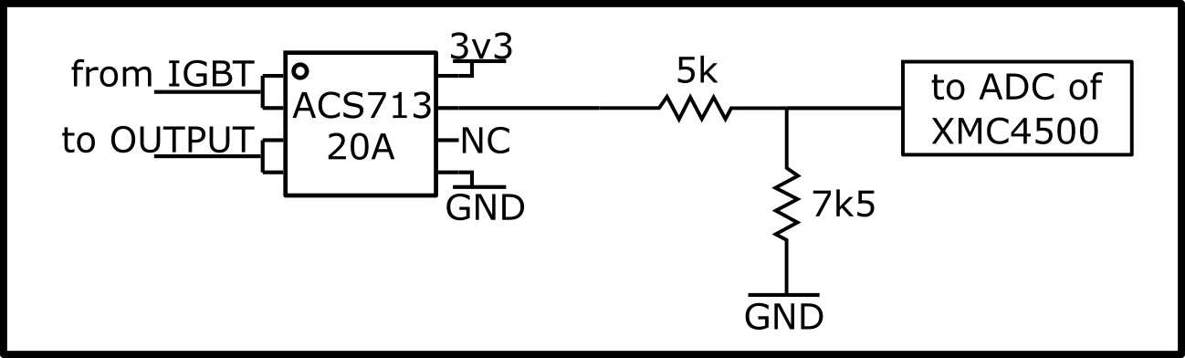

Figure 4 - Schematic for internal current measurment. NOTE1: the resistors can be removed to reach the maximum scale of the ADCs; NOTE2: for the external measurement, the same circuit is employed, without resistors.

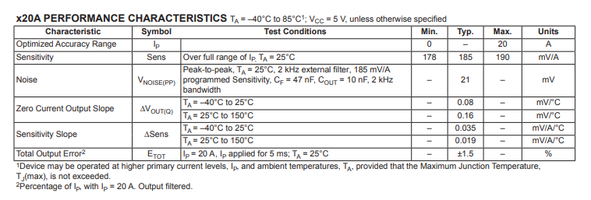

Figure 5 - Detail of the datasheet

In the provided code, the acquisition is performed at the beginning of the 10 kHz interruption, in the “Update_PWM(void)” function:

**/// ADC acquisition - AC Currents**

I_abc_adc[0]=ADC_MEASUREMENT_ADV_GetResult(&ADC_MEASUREMENT_2_V2_2);

I_abc_adc[1]=ADC_MEASUREMENT_ADV_GetResult(&ADC_MEASUREMENT_1_V1_4);

I_abc_adc[2]=ADC_MEASUREMENT_ADV_GetResult(&ADC_MEASUREMENT_1_V1_3);

I_abc[0]=(I_abc_adc[0]- (1800.0f + 74.8f)) * 0.022222222f;

I_abc[1]=(I_abc_adc[1]- (1800.0f + 77.0f)) * 0.022179506f;

I_abc[2]=(I_abc_adc[2]- (1800.0f + 70.8f)) * 0.021897810f;

Due to the precision of the resistors in the resistor divider, an offset and gain error occurs. A practical calibration of each sensor is recommended, with the calibration procedures presented in section 6.4.

## DC_BUS Voltage Measurement

The DC bus voltage measurement is performed with an isolation amplifier, namely the [AMC1311](http://www.ti.com/product/AMC1311), as illustrated in the following figure:

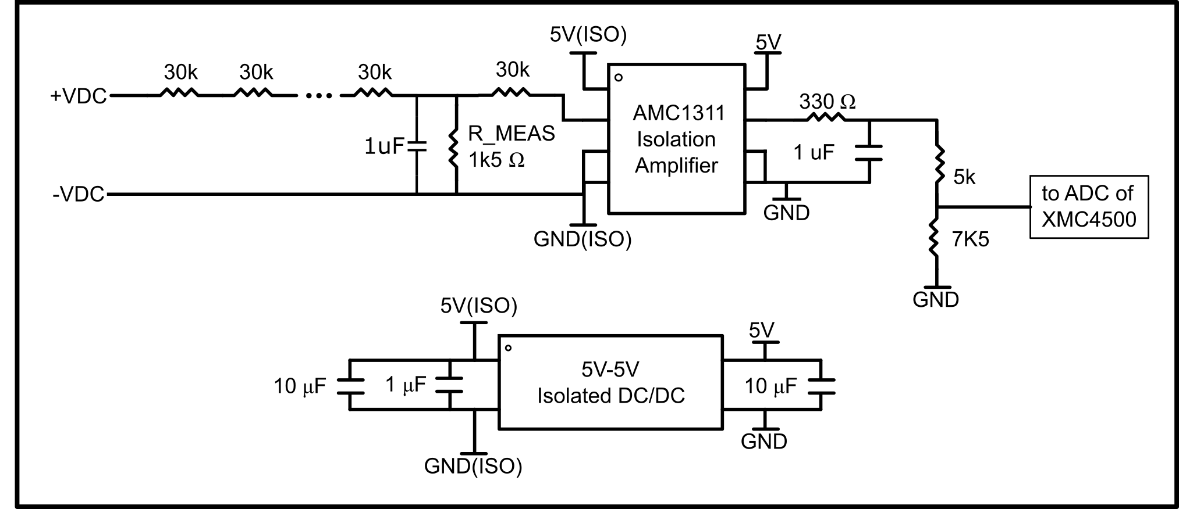

Figure 6 - Schematic for DC voltage measurement

Similarly, in the provided code, the acquisition is performed at the beginning of the 10 kHz interruption, in the “Update_PWM(void)” function:

**/// ADC acquisition – DC_BUS Voltage**

V_DC_adc = ADC_MEASUREMENT_ADV_GetResult(&ADC_MEASUREMENT_1_V1_2);

V_DC = (V_DC_adc-(1800.0f + 22.4f)) * -0.58f;

Due to the precision of the resistors, an offset and gain error occurs. A practical calibration of each sensor is recommended, with the calibration procedures presented in section 6.4.

## AC Voltage Measurements (Three Measurements)

Similarly to the DC Bus Voltage measurement, AC voltage measurement is performed with an isolation amplifier, as illustrated in the following figure:

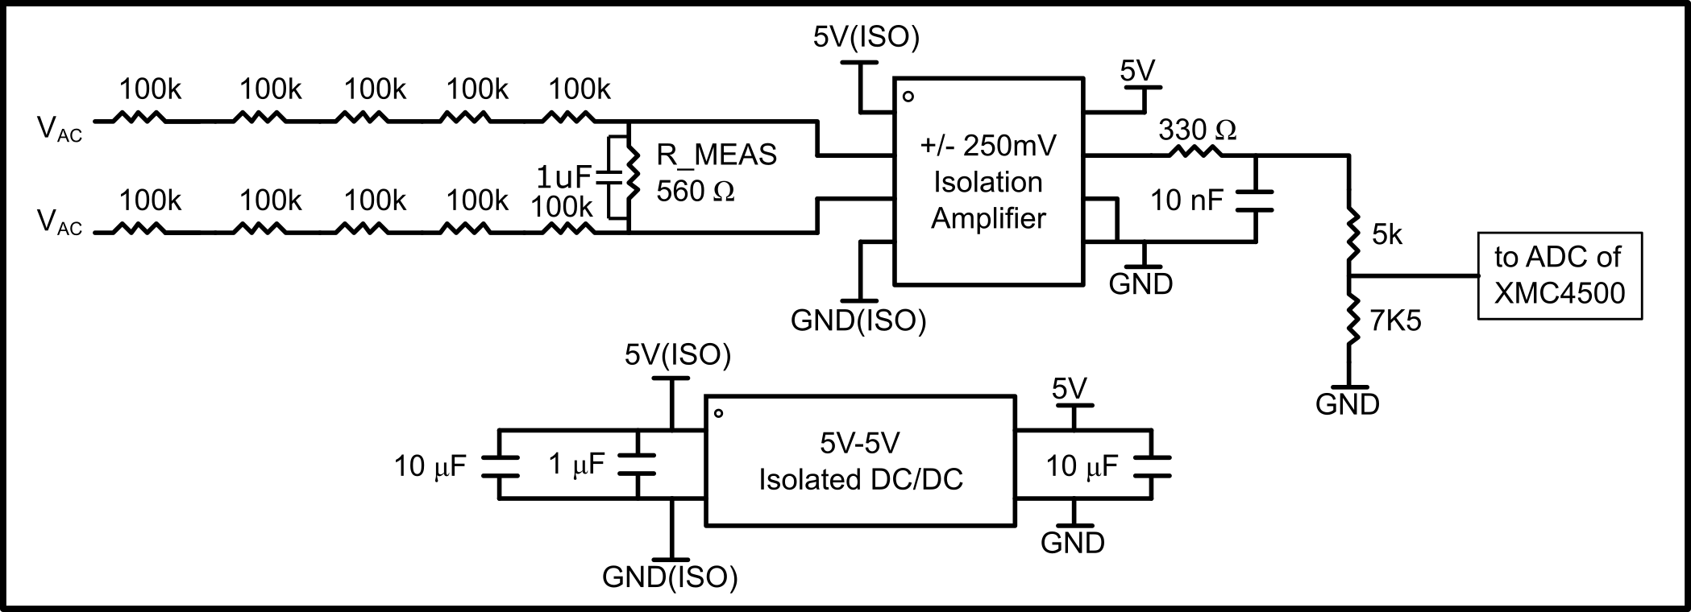

Figure 7 - Schematic of AC voltage measurement

In the provided code, the acquisition is performed at the beginning of the 10 kHz interruption, in the “Update_PWM(void)” function:

**/// ADC acquisition - AC Voltages**

V_abc_adc[0]=ADC_MEASUREMENT_ADV_GetResult(&ADC_MEASUREMENT_1_V1_1);

V_abc_adc[1]=ADC_MEASUREMENT_ADV_GetResult(&ADC_MEASUREMENT_2_V2_1);

V_abc_adc[2]=ADC_MEASUREMENT_ADV_GetResult(&ADC_MEASUREMENT_2_V2_3);

V_abc[0]=(V_abc_adc[0]- (1800.0f + 23.92f)) * 0.720f;

V_abc[1]=(V_abc_adc[1]- (1800.0f + 16.50f)) * 0.720f;

V_abc[2]=(V_abc_adc[2]- (1800.0f + 2.930f)) * 0.720f;

Due to the precision of the resistors in the resistor divider, an offset and gain error occurs. A practical calibration of each sensor is recommended, with the calibration procedures presented in section 6.4.

## Temperature measurement

Based on the built-in thermistor of IKCM30F60GA IGBT module, the temperature is acquired, with the following code:

float conv_temperature = ADC_MEASUREMENT_ADV_GetResult(&ADC_MEASUREMENT_3_V3_1);

float conv_temp_C =(conv_temperature*conv_temperature*-0.00016973) + //x^2

(conv_temperature*0.69969095) + //x^1

-653.10731030; //x^0

conv_temp_C += 7.0f; //offset compensation (junction temperature)

This is performed with the isolation amplifier AMC1311.

## PINOUT

|  |  |  |
| --- | --- | --- |
| Functional pin | XMC4500 pin | description |
| Vabc_0 | P14.1 | Voltage AC |
| Vabc_1 | P14.3 | Voltage AC |
| Vabc_2 | P14.5 | Voltage AC |
| Vdc_bus | P14.7 | Voltage DC bus |
| Temp_IPM | P14.13 | IPM temperature (termistor) |
| Iabc_1 | P14.8 | Current at phase Iu |
| Iabc_2 | P14.2 | Current at phase Iv |
| Iabc_3 | P14.0 | Current at phase Iw |
| Irst_0 (Flat cable 2) | P15.2 | Current at grid side phase R |
| Irst_1 (Flat cable 3) | P14.14 | Current at grid side phase S |
| Irst_2 (Flat cable 4) | P14.12 | Current at grid side phase T |
| EXTRA (Flat cable 5) | P14.6 | NOT USED |
| EXTRA (Flat cable 5) | P14.4 | NOT USED |

# Version control

V1.0 – preliminary – [v.morais@fe.up.pt](mailto:v.morais@fe.up.pt)

V1.1 – added PWM generation details, ADC details and minor updates in the How to use section – [v.morais@fe.up.pt](mailto:v.morais@fe.up.pt)

V1.2 – Major revision for REV 4.0 – [vmorais@fe.up.pt](mailto:vmorais@fe.up.pt)